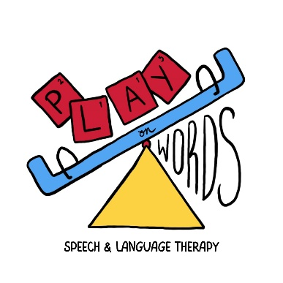

Service Rate Schedule

(July 6, 2024)

|  |  |  |
| --- | --- | --- |
| Service | Typical Time | Fee per Session |
| Speech and Language Evaluation | 2 hours | $225 |
| Speech Evaluation Only | 1 hour | $150 |
| Other Evaluations | Varies | Varies |
| Speech or Language Therapy – Individual | 50 minutes | $90 |
| 25 minutes | $45 |
| Game-Based Language & Social Communication Group | 2 hours | $50 per participant;  4 participants required |
| Aquatic Communication Therapy  *No prompt pay discount offered | 6-week session | $340 |
| 25 minutes | $60 |
| Consultation | 1 hour | $90 |
| Travel*  (fee to & from client’s location based on distance driven and time used) | 15 min/5 miles  30 min/10 miles  45 min/15 miles | $25  $50  $75 |

**Private Pay Only**

*Superbill* for Insurance Reimbursement Provided

*Prompt-Pay Discounts* are applied for payments made at the time of service

$50 off evaluations

$20 off therapy sessions and consultations

*Services may be provided at Play on Words LLC collaborating facilities or in the client’s home. If home-based services are provided, a travel fee reflecting the distance from Play on Words LLC’s business address.